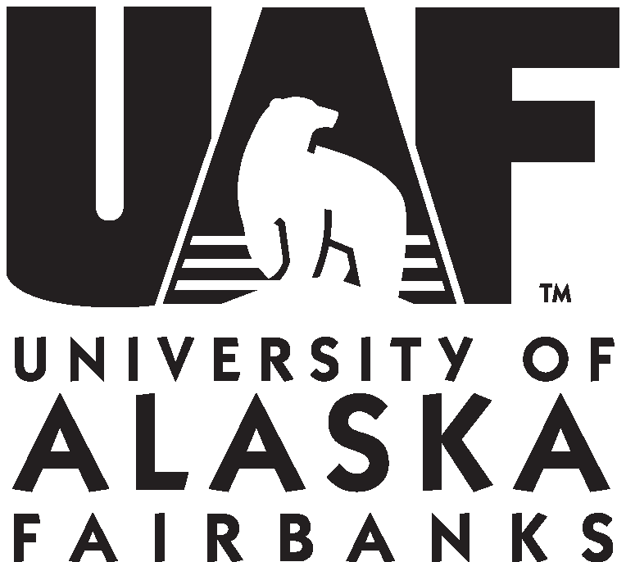

2017-2018 William and Dorothy Jane

Wood Talent Grant Application

Former University of Alaska President William R. Wood, and his wife, Dorothy Jane, were longtime and ardent supporters of the university. This talent grant endowment was funded and grown for many years through the Crossroads fashion show held by the UAF College of Fellows. The purpose of the grant is to recruit and retain students at the University of Alaska Fairbanks who exhibit exceptional potential for excellence in the fine arts and to encourage them to further develop their talent while enrolled at UAF. Applicants for this award must submit an essay, a letter of recommendation from high school or university faculty, and a talent portfolio. One or several awards (minimum $1000) will be made at the discretion of the selection committee.

- Name:______________________________________

- Student I.D. :________________

- Alaska Resident:
- No
- Yes, since (year) _________

- High School Graduation Date: __________________
(or GED completion date)

High School Location: ________________________
(or GED center) city state

- Enrollment Status during Fall 2017:
- Full time (12 credits undergraduate; 9 credits graduate)
- At least half time (6 or more credits each term)

- Your academic major, select one of the following:
- Art
- Music ( Instrument:_________________________)
- Film & Performing Arts
- Emphasis within your major (list or describe):
________________________________________________

- Current Cumulative G.P.A. (this should match your transcripts - do NOT send in transcripts): __________
(If you are still in high school, please use your high school cumulative G.P.A.; if you have completed at least one semester of college, please use your college cumulative G.P.A.)

9. Please describe in an essay of approximately 500-750 words why you should be considered for this talent grant. Also please include your academic goals and how you hope to use your education.

10. Please request a letter of recommendation from a faculty member, teacher, employer, or private instructor who is familiar with your talents and academic achievement. Confidential letters (not required) may be submitted in sealed envelopes.

11. In order for the selection committee to evaluate your talent and potential, please submit one of the following:
A. Visual Art: Five (5) portfolio samples. Please send as PDF files.
B. Music and Theatre/Film: Two (2) contrasting performances. Please send your submission through YouTube. Music applicants are encouraged to submit high quality video.

DIGITAL MATERIALS ARE STRONGLY PREFERRED!

I certify that the information I have provided on this application is true and correct to the best of my knowledge. I authorize the Office of the Registrar to release my academic information to the Scholarship Committee and other third
parties for the purpose of scholarship consideration. I give permission for the University of Alaska Fairbanks or the UA Foundation to release information about myself and the name and amount of the scholarship if I am awarded a scholarship based on this application.

Signature (required): ________________________________________________ Date: ___________________

Applicants should submit this application and an essay with a letter of recommendation and portfolio/performance samples. All application materials must be received (not postmarked) by 5:00 p.m. on May 8, 2017. Deliver, email, fax, or mail completed application materials to:

Scholarship Coordinator
c/o UAF Financial Aid Office
Room 107 Eielson Building.
PO Box 756360
Fairbanks, AK 99775-6360
uaf-scholarships@alaska.edu
fax: (907) 474-7065
All application materials must be received (not postmarked) by 5:00 p.m. on May 8, 2017.

