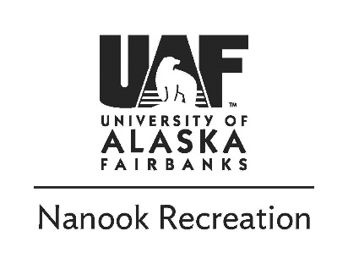
Fielding Lake Canoe and Hike | 9.2.2019
UAF Student $60 Staff/Faculty $72

Monday, September 2nd (Labor Day)
8:00am -Meet at Outdoor Adventures
11:00am -Arrive at Fielding Lake
4:00pm -Return to vehicles and head back with a possible dinner stop
7:00pm -Arrive at UAF (later if there’s a dinner stop)

Trip description:
Fielding Lake is a beautiful location for a flatwater canoe experience. We will drive to the Delta Mountains area and put in at the Fielding Lake boat launch. We will canoe around the lake and land for lunch and a day hike on the surrounding terrain. If we are lucky, we will find some late-season blueberries.

Things to bring:
- Backpack or duffle to hold lunch and gear for the day
- PFD- Personal flotation device (OA will provide)
- Small Drybag(OA will provide)
- Rubber boots or shoes for canoeing (OA can provide noeprine booties)
- Rain Jacket and Pants
- Light puffy coat
- Warm socks
- Non-cotton clothes -Mid or Light fleece top and bottoms
- Extra layers for slightly warmer or colder conditions
- Wool or synthetic hat
- Sunglasses, sun block, and bug repellent
- Snacks and lunch for a long day out
- 1-2 liters of water
- $10-20 for optional dinner stop on the way back

Items in Bold Face are available from Outdoor Adventures for free use on our trips!

Refund Policy:
Payment in full is required to sign up for a trip. A 100% refund is available if you notify the Outdoor Adventures Office of the cancellation more than two weeks (14 days) before the first day of the trip. Cancellation two weeks to 3 days (13 to 3 days) before the trip entitles the participant to a 50% refund. No refund is provided if the participant does not show up or cancels 2 days or less prior to the trip.

Risk Tolerance:
Due to the nature of outdoor travel there are certain inherent risks in all of Outdoor Adventure’s trips. Acceptable risks include but are not limited to: flipping a canoe, getting wet while on the trip, and unpredictable weather. We will wear PFD’s at all times on the water. Conditions may include below freezing temperatures, thunderstorms, rain, sleet and high winds. Driving risks may include slick roads, poor visibility and wildlife. Alaska is a wild place - you need to take ultimate responsibility for your own safety as only you can. For your protection we require you to carry health insurance. You can purchase insurance for $2.60/day from the University (ask for details). All info is subject to change due to safety, weather, current conditions, etc.!

If you have any questions please contact us or visit our office in the SRC
uaf-oa-staff@alaska.edu | 907.474.6027 | uaf.edu/recreation/outdoor-adventures

