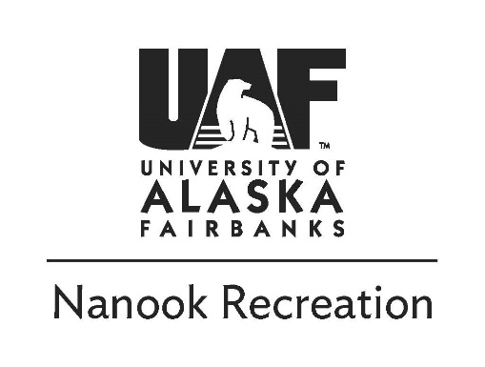
White Mountains Ski | 12.1.2019
UAF Students $25 Staff/Faculty $30
Sunday, December 1st
9:30am - Meet at Outdoor Adventures, grab skis and head out
11:00am - Arrive at trailhead

3:00pm -Drive back to Outdoor Adventures

Trip Description:
The White Mountains provide beautiful scenery and cross-country skiing is a great way to get out and stay active in the winter months. This XC ski trip is definitely beginner friendly, but it shouldn’t be your first time on skis due to the terrain (stop by our office for a lunch ski to get some experience or participate in our Learn to XC ski trip on 11.23). We will drive to Wickersham dome in the White Mountains and enjoy a mid-day winter ski!

Things to Bring:
- Skis, boots, and poles (provided by OA)*
- Small day pack
- Warm long johns top and bottoms, fleece top
- Shell Jacket (rain jacket, softshell or windbreaker)
- Shell pant or snow/ski pant
- Puffy coat
- Wool socks
- Wind resistant hat, neck gaiter and/or balaclava
- Warm Gloves and/or mittens
- 1L of water (A cover to keep it from freezing OA can Provide)*
- Lunch and snacks
* OA Provides these as part of the trip if needed

Refund Policy:
Payment in full is required to sign up for a trip. A 100% refund is available if you notify the Outdoor Adventures Office of the cancellation more than two weeks (14 days) before the first day of the trip. Cancellation one week to 3 days (13 to 3 days) before the trip entitles the participant to a 50% refund. No refund is provided if the participant does not show up or cancels 2 days prior to the trip.

Safety and Risk Management:
Due to the nature of outdoor travel there are certain inherent risks in all of Outdoor Adventure’s trips. Acceptable risks include skiing with a daypack for several miles over uneven terrain, including ditches, and up and down inclined slopes. Conditions may include below zero temperatures, snow showers, and high winds. Please note that trip cancellations are possible with temperatures colder than -20F. It is important to recognize that you are voluntarily participating in this activity. By choosing to participate, you agree that you appreciate and accept responsibility for these risks. Alaska is a wild place - you need to take ultimate responsibility for your own safety as only you can. For your protection we require you to carry health insurance. You can purchase insurance for $2.60/day from the University (ask for details). All info is subject to change due to safety, weather, current conditions, etc.!

If you have any questions please contact us or visit our office in the SRC
uaf-oa-staff@alaska.edu | 474-6027 | www.uaf.edu/recreation

