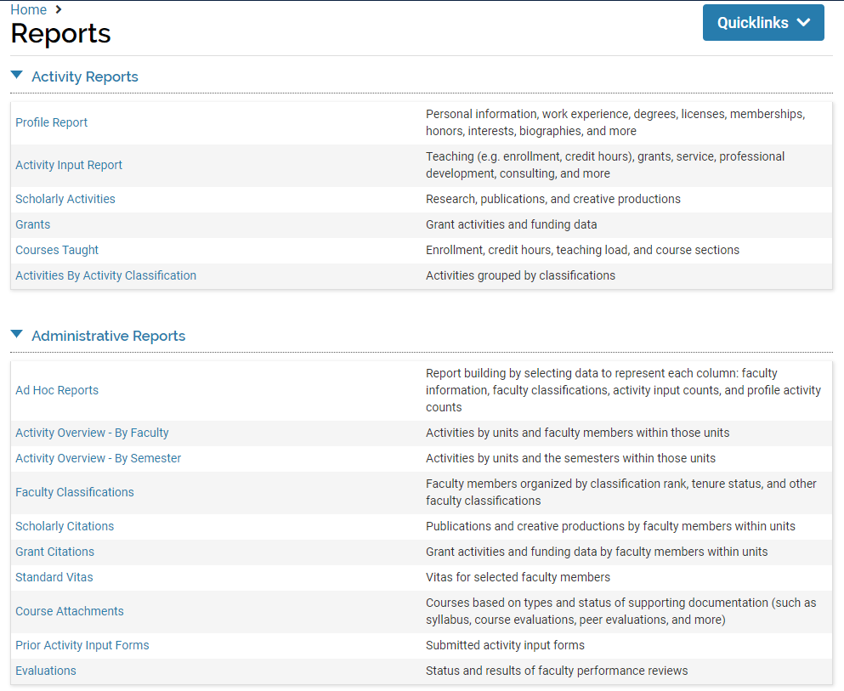
Profile Report: Run summary reports on information from faculty profiles, such as professional licensure or membership, or degrees earned.
Activity Input Report: Run a summary report by category of activity from the AARs, or run reports on a specific activity such as student advising, public service, etc.
Scholarly Activities: Run a summary report specific to research, scholarly and creative activity from the AARs, or run reports on a specific activity such as journal articles, poster presentations, etc. *Note, detailed scholarly activity list can also be produced under the “Scholarly Citations” administrative report.
Grants: Run a summary report of grants under your unit for a specific year, or customize to display total funding, direct or indirect funding, federal/state/corporate, etc.
Courses Taught: Due to extensive duplication in the system for team-taught courses and manually added courses, we do not recommend using Faculty 180 to report on any instructional-credit activities.
Activities by Activity Classification: Mostly useful for activity classifications used in accreditation indicators; run a report based on specific classifications such as “Showcase activity for CAEP” or “Incorporates indigenous knowledge.”
Ad Hoc Reports: Create and save your own customized reports based on your unit’s needs. This option will take the most time to do, but may be worth the investment if you have highly unique reporting needs.
Activity Overview – By Faculty: Run a summary report of all activities or of a specific activity category, with results displayed by faculty member.
Activity Overview – By Semester: Run a summary report of all activities or of a specific activity category, with results displayed by semester.
Faculty Classification: See a summary of faculty broken out by classifications such as employment status, NCATE assignment, union affiliation, tenure status, etc.
Scholarly Citations: Run a report of all scholarly activities in citation format (select from a list of options) and display by faculty or by activity type.
Activity Overview – By Semester: Run a summary report of all activities or of a specific activity category, with results displayed by semester.
Standard Vitae: Get a list of CVs or AARs for all faculty in your unit, with links to open and print.
Course Attachments: Set a reporting period and view a list of courses that have attachments (syllabi, evaluations, etc.) provided, with links to open and print.
Prior Activity Input Forms: Set the semester to one within the reporting year you want, and view a list of faculty that submitted AARs, with links to open and print.
Evaluations: Shows evaluation completion for selected time period; not currently available because UAF does not utilize the Faculty180 evaluation process.
AAACSB – 2013 (business): These three reports are designed for School of Management reporting to the AACSB accrediting body.
AAACSB – 2017 (business): These four reports are designed for School of Management reporting to the AACSB accrediting body.
CES Reports: These four reports are designed to meet Cooperative Extension Services’ reporting needs for federal grant funding.
NCATE-CAEP (education): This report is related to School of Education reporting to the CAEP (formerly NCATE) accrediting body.
Regional Accreditation: These two reports are designed to produce faculty reports for regional accreditation.

