2019-20
UNAC FACULTY
Guidelines for Travel Awards

Deadlines:
- November 29, 2019 Fall 2019 Travel (August – December 2019)*
- December 20, 2019 Spring 2020 Travel (January – May 2020)
- February 21, 2020 Summer 2020 Travel (June – July 2020)

*Applications for travel that occurred between August – October 2019 are eligible to be considered for reimbursement of travel.

Grant amount: $2500

Travel awards are available for UNAC faculty per article 5 of the CBA.

Faculty Travel Awards for professional development are available through the Provost Office and will require at least one of the following:

- Presentation of original paper at a scholarly and professional meeting/conference
- Invitation to participate at a regional, national or international exhibition or performance
- Research or creative activity that leads directly to exhibition, performance or publication
- Faculty development at teaching or learning conferences

The application must include:
- A brief description of the activity, including the submitted abstract, program schedule or letter of invitation, if applicable
- A description of how this will contribute to your development as a faculty member
- If it is for travel when classes are in session, a plan should be included for how classes will be covered during the absence
- Signature of Approval from the department chair and dean/institute director for this activity

Only completed applications will be accepted for consideration

Faculty members may be eligible to receive one travel grant award during a fiscal year (July 1 – June 30). Not all applications will be approved based on the amount of travel funds available. The travel funds are available and open to all UNAC faculty members, but preference will be given to those faculty who have completed their required employee training (e.g., Title IX, FERPA or Safety trainings) and who have NOT received UNAC travel awards in the past year. Faculty members on sabbatical may apply for the travel award, but preference will be given to faculty members who are not on sabbatical.
All proposals must be sent to the Office of the Provost either by email at uaf-provost-awards@alaska.edu or dropped off at 311 Signers’ Hall by the deadline date. Please contact the Provost’s Office at 474-7096 for questions.

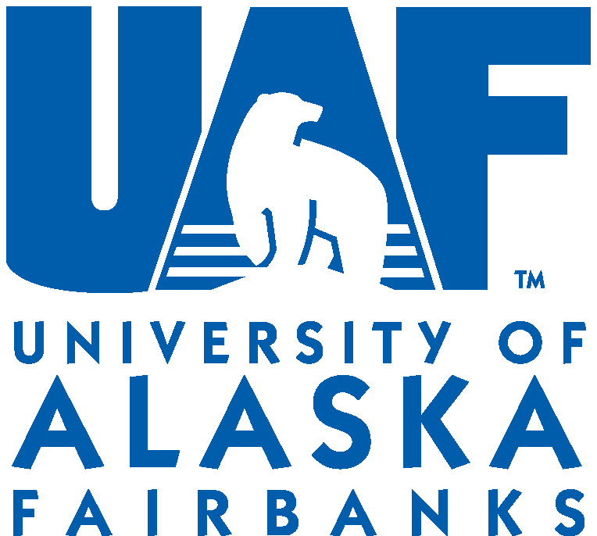
2019-20
UNAC Travel Grant Application

Deadlines:
- November 29, 2019 Fall 2019 Travel (August – December 2019)*
- December 20, 2019 Spring 2020 Travel (January – May 2020)
- February 21, 2020 Summer 2020 Travel (June – July 2020)

*Applications for travel that occurred between August – October 2019 are eligible to be considered for reimbursement of travel.

Faculty Travel Awards for professional development are available through the Provost Office and will require at least one of the following:
- Presentation of original paper at a scholarly and professional meeting/conference
- Invitation to participate at a regional, national, or international exhibition or performance
- Research or creative activity that leads directly to exhibition, performance or publication
- Faculty development at teaching or learning conference

Please fill out this form completely and include all necessary information, attachments, and signatures.
Applications will be evaluated by the UNAC Travel Grant Committee. Successful applicants will be notified as soon as possible. Faculty members may be eligible to receive ONE travel grant awards during a fiscal year (July 1 – June 30). Not all applications will be approved based on the amount of travel funds available. Travel funds are available to all UNAC members, but preference will be given to non-tenured, tenure-track faculty.
Check one of the following:
FALL 2019 TRAVEL SPRING 2020 TRAVEL SUMMER 2020 TRAVEL
Date of Submission: ____________________________
Faculty Member Name: ____________________________ Email: ___________________ Phone: __________
Academic Unit(s): __________________________________________________________________
Academic Rank: ______________________________ Tenure status: ______________________
Conference/Activity Title: __________________________________________________________________
Dates of Travel: ______________________________ Location: ________________________________
*Executive Officer/Fiscal Technician’s Name: ____________________ Email:_________________________

Provide the following information as appropriate:

Brief description of the conference and attach a copy of the invitation received and/or abstract submitted:

Brief description of how the activity contributes to faculty development or to a publication or other product:

Other available support or sources to help fund this activity/travel:

Explanation of how classes will be covered during your absence (if it is for travel when classes are in session):

SIGNATURES
The following signatures are required. Proposals will not be accepted unless all signatures have been collected.

Faculty Member Signature (signature required): __________________________________________
Department Chair Approval (signature required): __________________________________________
Dean/Director Approval (signature(s) required): __________________________________________

*Travel Grant Fiscal Process:
The Executive Officer or Fiscal Technician overseeing the faculty member’s department fiscal processes. The faculty member is responsible for submitting all travel paperwork to his/her executive officer and/or fiscal technician in order to receive the grant from the Provost Central Fiscal Administrative Office.

