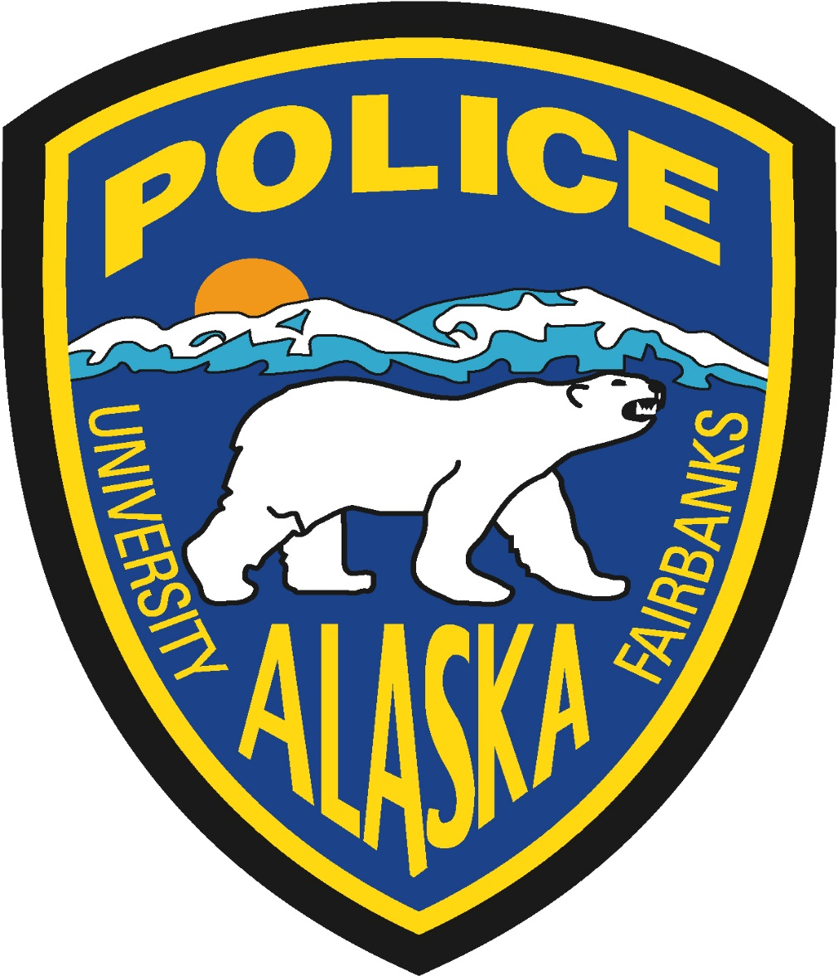

UAF Police Department
Police Officer Recruitment
Detailed Application Guide

Please read this instruction packet thoroughly BEFORE applying to be considered for any UAF Police Officer position.

Successful applicants will be hired as either a Police Officer 1, Police Officer 2, or Police Officer 3, depending on qualifications and experience. Salary at each level is DOE.
Contact Laurii Woodruff, UAF Police Department at 907-474-6290 for questions on the recruitment or submitting your application.
Recruitment overview
University of Alaska Fairbanks Police Officers are responsible for all law enforcement and criminal investigations on the UAF Campus. Must be able to respond to situations where the threat to the officer is unknown. Must be able to quickly assess the situation and act appropriately and in accordance with departmental policy and state statutes. Must be aware of role within a sensitive university setting. Must be of good moral character, free of cultural and ethnic bias. Personal conduct should be above reproach. Strong desire to protect and serve the community. Must maintain physical fitness standards. Must meet all eligibility requirements of Alaska Police Standards Council per 13 AAC 85.005-120. Must have Alaska Driver’s License at the time of hire.
Basic Requirements:
Police Officer 1: US Citizen, 21 years of age, successful completion of Civilian Law Enforcement Academy of 650 hours or more preferred. Starts at grade 77
Police Officer 2: US Citizen, 21 years of age, successful completion of Civilian Law Enforcement Academy, Alaska Police Standards Council Basic Certification. Starts at grade 79
Police Officer 3: US Citizen, 21 years of age, successful completion of civilian Law Enforcement Academy, Alaska Police Standards Council Intermediate or higher Certification, 10 years total full-time civilian law enforcement, or 4 years and an associate degree or 96 credit hours, or 3 years and a bachelor degree. Must have completed total of 184 training hours, after FTO, during law enforcement employment. Starts at grade 80

In order to be considered for the UAF Police Officer recruitment, the following must be accomplished:
- Apply to recruitment http://www.alaska.edu/jobs/

- Do not submit your application until all required documents are uploaded.

- If you do not have a document as it does not apply, please submit one page with your name on it that states “does not apply” and submit in place of document.

- Upload resume, cover letter and list of three professional references.

- Submit signed and notarized Alaska Police Standards Council F-3 form. Form found at https://dps.alaska.gov/getmedia/cb881423-1577-46a3-9278-68a460cca123/F-3.pdf;.aspx
You must upload your signed, notarized, and scanned APSC F-3 form as a PDF or your application will be considered incomplete. Free notary service is available at UAF Police Dept.
- The required additional documents must be uploaded as supporting documents or your application will be considered incomplete.
Documents required for uploading to application prior to submitting application:
- Required for all- APSC F-3 signed and notarized
- Required for all- copy of birth certificate or passport
- Required for all- copy of transcripts for high school showing graduation, diploma or GED
- Required for all- copy of current driver’s license
- Required for all- copy of vehicle registration for all vehicles owned
- Required for all- copy of insurance for all vehicles owned
- Required for all- transcripts for college degree or classes attended
- Civilian Law Enforcement Academy Certificate- if attended and completed
- Prior military only- copy of DD-214
- Current Alaska Law Enforcement only- APSC certificate
- Other state Law Enforcement Certificate -for those certified outside the State of Alaska

Those applicants who have successfully submitted required documents to the recruitment will be invited to the physical fitness test. Invitation will be done via email and testing will be done in Fairbanks Alaska on UAF campus.
- The multiple section written test will be setup for those that pass the PT test.
- Interview times will be assigned for those that pass the written test.

Process of recruitment:
- Applicants will be screened for minimum requirements and having all documents submitted
- Applicants will be notified by email of the testing dates, times and locations.
- Fitness testing
- Written testing
- Oral interviews
- Polygraph
- Background investigation
- Conditional job offer
- Psychological assessment
- Medical Exam
- Final Offer Given

Equal Opportunity/Affirmative Action:
The University of Alaska is an equal employment opportunity/affirmative action employer and educational institution. All qualified applicants will receive consideration for employment without regard to race, color, religion, sex, national origin, disability status, protected veteran status, or any other status protected by law.
UA is an AA/EO employer and educational institution and prohibits illegal discrimination against any individual: www.alaska.edu/titleIXcompliance/nondiscrimination.
Training Policy:
It is the policy of the University of Alaska Fairbanks that all employees are required to attend training to meet the requirements of the positions they hold, and to complete the required training within a specified period of time to remain employed at UAF. The policy can be located at: http://www.uaf.edu/chancellor/policy/04.07.010/
Tobacco-Free Campus:
UAF Campus is a tobacco free campus. For more information, please go to: http://www.uaf.edu/tobaccofreecampus/

