INVENTING THE SUIT AND SAVING THE WORLD: ONE HUMAN’S STORY OF UNPARALLELED GENIUS, INTERMINABLE COURAGE, AND GENERAL AWESOMENESS

by
Anthony Stark
B.S. University of Pirates, 2017
M.S. College of Technology, 2019

A Dissertation Submitted in Partial Fulfillment of the Requirements
for the Degree of

Doctor of Philosophy
in
Engineering

University of Alaska Fairbanks
August 2025

APPROVED:
Bruce Banner, Committee Chair
Thor Odinson, Committee Member
Natasha Romonoff, Committee Member
Jane Van Dyne, Committee Member
Clinton F. Barton, Chair
Department of Mechanical Engineering
Jean Gray, Dean
College of Business and Security Management
Emeline Jones, Director
Graduate School

Copyright

© Copyright by Anthony Stark
All Rights Reserved

Dedication
To Wanda Maximoff:

Write as a block (or single paragraph) with no indentation. The dedication is optional. A dedication is an expression of friendly connection, gratitude, or thanks by the author towards another person or person(s). It may also be used to highlight a connection to a community or cause. Adapted from Wikipedia. The dedication has its own place on the dedication page and is part of the front matter.

Abstract
Abstract to be less than 300 words. The abstract is required. Write as a single block with no indentation. An abstract is a concise summary of your dissertation. It should summarize your dissertation, its results, and its broader relevance. It allows readers determine the relevance of your dissertation to their own research and serves as an invitation to them to read it. It also communicates your key findings to those who don’t have the time to read your entire dissertation.

Plain Word Summary
Plain word summary to be less than 300 words. The plain word summary is optional. Write as a single block without indentation. A plain word summary should convey the same information as the abstract but in a different language and tone. It should summarize your dissertation, its results, and their broader relevance without using jargon so that it is understandable by readers from outside of your discipline, as well as journalists and educators. The audiences include, but are not limited to, practitioners, policy makers, the public, and/or professionals in nearby disciplines.

Acknowledgements
Write as a paragraph, or paragraphs, with indentation. The acknowledgements section is optional. The acknowledgments section is where you recognize and thank everyone (mentor/advisor committee, friends, family, colleagues, communities, organizations, agencies) who helped you with your dissertation and contributed to your success. It’s a way to show your appreciation and recognition of them in a public and permanent forum. You can also include a Land Acknowledgement in the acknowledgements. It is also the section where you can formally report any agencies and organizations that provided financial or other material support for your work (e.g., I acknowledge the support of the UAF graduate school for …., I thank Foundation X for ….). I acknowledge the support of the graduate school for a travel grant in Fall 2022. I acknowledge the support of the National Science Foundation under grant 2012345.

Table of Contents

Copyright iii
Dedication iv
Abstract v
Plain Word Summary vi
Acknowledgements vii
Table of Contents viii
List of Figures x
List of Tables xi
Chapter 1: General Introduction 1
1.1 References 1
Chapter 2: First Paper Title 2
2.1 Abstract 2
2.2 Introduction 2
2.3 Methods 3
2.3.1 Study System 3
2.3.2 Mathematical Equation 3
2.3.3 Statistical Model 3
2.3.4 Chemical Reactions 4
2.4 Results: Long ToC entries should not extend into the numbers column. They should stop before reaching the number 4
3.3 Survey Results 4
2.4.1 Steady State Solution 5
2.4.2 Non-territorial Individual Analysis 6
3.3 Survey Results 6
2.5 Discussion 7
2.6 References 7
Chapter 3: Second Paper Title 8
3.1 Abstract 8
3.2 Introduction 8
3.3 Methods 9
3.3.1 Study System 9
3.3.2 Mathematical Model 9
3.3.3 Statistical Model 9
3.4 Results 10
3.4.1 Steady State Solution 10
3.4.2 Non-territorial Individual Analysis 13
3.5 Discussion 13
3.6 References 13
Chapter 4: General Conclusions 14
Appendix A: Supplemental Material 15
Appendix B: More Supplemental Material 16

List of Figures
Figure 2.1: A very studious and well-read sloth just got a new pair of eyeglasses and wonders if others love them as much as he does. 2
Figure 3.1: A capybara wearing a suit. Probably has an important meeting to get to. 8
Figure A.1: Frog looking real dapper. 15

List of Tables
Table 2.1: Model components and parameters making up advection diffusion model as well as biological interpretation in model’s system. 5
Table 2.2: They all seem to be negative. Maybe that’s significant? Maybe it’s not. Why are a bunch of them 0.1? 6
Table 3.1: Model components and parameters making up advection diffusion model as well as biological interpretation in model’s system. 10
Table 3.2: Counts of all the stuff, things, doodads, trinkets, artifacts, and entities. 11

General Introduction
Lorem ipsum dolor sit amet, consectetuer adipiscing elit. Ut purus elit, vestibulum ut, placerat ac, adipiscing vitae, felis. Curabitur dictum gravida mauris. Nam arcu libero, nonummy eget, consectetuer id, vulputate a, magna. Donec vehicula augue eu neque. Pel- lentesque habitant morbi tristique senectus et netus et malesuada fames ac turpis egestas. Mauris ut leo. Cras viverra metus rhoncus sem. Nulla et lectus vestibulum urna fringilla ultrices. Phasellus eu tellus sit amet tortor gravida placerat. Integer sapien est, iaculis in, pretium quis, viverra ac, nunc. Praesent eget sem vel leo ultrices bibendum. Aenean faucibus. Morbi dolor nulla, malesuada eu, pulvinar at, mollis ac, nulla. Curabitur auctor semper nulla. Donec varius orci eget risus. Duis nibh mi, congue eu, accumsan eleifend, sagittis quis, diam. Duis eget orci sit amet orci dignissim rutrum.

1.1 References
Einstein, A., Darwin, C. & Linnaeus, C. (1425) The hungry hungry moose. Journal of Hungry Animals. 3, 2150–8925.
Styles, H., Horan, N., Payne, L., Tomlinson, L. &Malik, Z. (1985) How many directions are there: Only the one. Scandinavian Journal of Music. 12, 97–15.

First Paper Title

2.1 Abstract
Present the abstract as it appears in the paper as a single paragraph with indentation.

2.2 Introduction
If you decide to embed figures in your document, you must mention that figure within 1.5 pages of where that figure is found. You can have all of your figures for each chapter under a “Figures” heading found before your “Reference” section for that chapter. You can center-align or left-align your figures and figures captions but make sure you are consistent throughout. Additionally make sure figures are named for the chapter in which they are found and the number sequence that they are provided. For example, Figure 2.1 below is labeled Figure 2.1 because it is the first figure found in chapter 2. Finally, figure labels and captions belong below the figure on the same page as the figure.

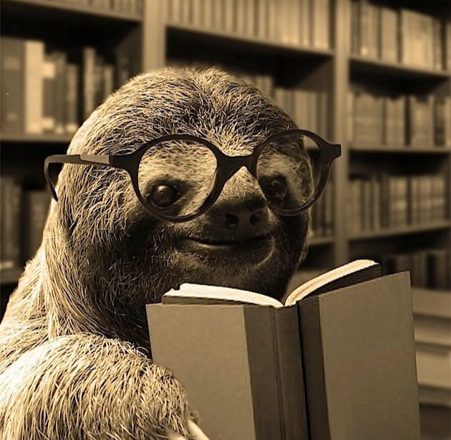
Figure 2.1: A very studious and well-read sloth just got a new pair of eyeglasses and wonders if others love them as much as he does.

2.3 Methods

2.3.1 Study System
Nam dui ligula, fringilla a, euismod sodales, sollicitudin vel, wisi. Morbi auctor lorem non justo. Nam lacus libero, pretium at, lobortis vitae, ultricies et, tellus. Donec aliquet, tortor sed accumsan bibendum, erat ligula aliquet magna, vitae ornare odio metus a mi. Morbi ac orci et nisl hendrerit mollis. Suspendisse ut massa. Cras nec ante. Pellentesque a nulla. Cum sociis natoque penatibus et magnis dis parturient montes, nascetur ridiculus mus. Aliquam tincidunt urna. Nulla ullamcorper vestibulum turpis. Pellentesque cursus luctus mauris.

2.3.2 Mathematical Equation
Mathematical equations that are aligned in the center. The labelling for each equation should be according to their chapter and the order in which you mention them in the text. For example, the first equation in chapter 2 would be Eq. 2.1 as shown below. Make sure that the equation labels line up at the same place at the right margin. Lastly add a space between bulk text and the start/end of a reaction, but not between multiple equations.

$$\begin{aligned}\frac{∂u_{i}}{∂t}=\underset{\text{Random Motion}}{\underbrace{D∇^{2}u_{i}}}-\underset{\text{Directed Motion}}{\underbrace{2∇\left[A_{i}∇u_{i}\right]}}\#(Eq.2.1)\end{aligned}$$

2.3.3 Statistical Model
Add statistical models as equations that are aligned in the center. The labelling for each model should be according to their chapter and the order in which you mention them in the text and are looped in with all equations numbering-wise. For example, the first statistical model in chapter 2 would be Eq. 2.2 as shown below because it is the second equation, even though it is the first statistical model. Make sure that the equation labels line up at the same place at the right margin. Lastly add a space between bulk text and the start/end of a reaction, but not between multiple models.

$$\begin{aligned}f\left(x | y, θ_{0}\right)= \frac{ϕ\left(x | y,θ_{0}\right) ω\left(x,β\right)}{\int_{Ω}{ϕ\left(x^{'} | y,{θ^{'}}_{0}\right) ω\left(x^{'},β\right)}}\#\left(Eq. 2.2\right)\end{aligned}$$

2.3.4 Chemical Reactions
Add chemical reactions as equations but do not format or label them in same way or sequence with other equations. Align the reactions to the left instead of center and make sure to label each reaction according to their chapter and order in which you mention them in the text. For example, the first two reactions in chapter 2 would be R 2.1 and R 2.2 as shown below. Make sure that the reactions start at the same place on the left margin and that the reaction labels are at the same place at the right margin. Lastly add a space between bulk text and the start/end of a reaction, but not between multiple reactions.

$${SO}_{2}(g)+ H_{2}O(aq)⇌ {SO}_{2}·H_{2}O(aq) (R 2.1)$$
$${SO}_{2}·H_{2}O(aq) ⇌ {{HSO}_{3}}^{-}+{ H }^{+} (R 2.2)$$

2.4 Results: Long ToC entries should not extend into the numbers column. They should stop before reaching the number
Lorem ipsum dolor sit amet, consectetuer adipiscing elit. Ut purus elit, vestibulum ut, placerat ac, adipiscing vitae, felis. Curabitur dictum gravida mauris. Nam arcu libero, nonummy eget, consectetuer id, vulputate a, magna. Donec vehicula augue eu neque. Pel- lentesque habitant morbi tristique senectus et netus et malesuada fames ac turpis egestas. Mauris ut leo. Cras viverra metus rhoncus sem. Nulla et lectus vestibulum urna fringilla ultrices. Phasellus eu tellus sit amet tortor gravida placerat. Integer sapien est, iaculis in, pretium quis, viverra ac, nunc. Praesent eget sem vel leo ultrices bibendum. Aenean faucibus. Morbi dolor nulla, malesuada eu, pulvinar at, mollis ac, nulla. Curabitur auctor semper nulla. Donec varius orci eget risus. Duis nibh mi, congue eu, accumsan eleifend, sagittis quis, diam. Duis eget orci sit amet orci dignissim rutrum.

3.3 Survey Results
If you are going to identify specific participants and their contributions format is like this:
Participant 1. What participant 1’s contribution was.
Participant 2. What participant 2’s contribution was
Participant 3. What participant 3’s contribution was
If you include direct quotes that are only one-to-two sentences, please put them in quotations. For example, Participant one “said that they like cookies with ice cream but would choose ice cream over cookies if they had to chose only one”. If you are including quotes that are longer, more like the length of a paragraph, put it in block form like the following example. Participant 1 said:
I’ve always liked cookies, sure, but ice cream has my heart, there’s just nothing like it. The texture, the flavors, the way it melts, is unbeatable. Cookies are good, but they don’t quite do it for me on their own. But put the two together? That’s where the magic happens. A warm cookie with cold, creamy ice cream in the middle? That’s my ultimate favorite; nothing beats that combo.

2.4.1 Steady State Solution
Nam dui ligula, fringilla a, euismod sodales, sollicitudin vel, wisi. Morbi auctor lorem non justo. Nam lacus libero, pretium at, lobortis vitae, ultricies et, tellus. Donec aliquet, tortor sed accumsan bibendum, erat ligula aliquet magna, vitae ornare odio metus a mi. Morbi ac orci et nisl hendrerit mollis. Suspendisse ut massa. Cras nec ante. Pellentesque a nulla. Cum sociis natoque penatibus et magnis dis parturient montes, nascetur ridiculus mus. Aliquam tincidunt urna. Nulla ullamcorper vestibulum turpis. Pellentesque cursus luctus mauris.

Table 2.1: Model components and parameters making up advection diffusion model as well as biological interpretation in model’s system.
Parameter | Interpretation | Dimensions
x | spatial location | [1x2]
u_{i}(x,t) | individual territory | [1x1] (i=5)
V_{hr} | vector field defining available space | [1x1]
B(x) | perceptive range of individual | [1x12]
s_{j}(x,t|B(x)) | Spatially averaged effect in perceptive range | [1x1] (j=4)
B^{C}_{i,j} | effect of conspecific (from iSSA) | [5x5]

Table 2.2: They all seem to be negative. Maybe that’s significant? Maybe it’s not. Why are a bunch of them 0.1?
 | TET052 | TET030 | TET072 | TET062 | TET074
TET052 | - | -0.3 | -0.1 | -0.1 | -0.14
TET030 | -0.26 | - | -0.1 | -0.2 | -0.2
TET072 | -0.1 | -0.1 | - | -0.13 | -0.1
TET062 | -0.1 | -0.31 | -0.16 | - | -0.1
TET074 | -0.13 | -0.21 | -0.1 | -0.1 | -

2.4.2 Non-territorial Individual Analysis
Nulla malesuada porttitor diam. Donec felis erat, congue non, volutpat at, tincidunt tristique, libero. Vivamus viverra fermentum felis. Donec nonummy pellentesque ante. Phasellus adipiscing semper elit. Proin fermentum massa ac quam. Sed diam turpis, mo- lestie vitae, placerat a, molestie nec, leo. Maecenas lacinia. Nam ipsum ligula, eleifend at, accumsan nec, suscipit a, ipsum. Morbi blandit ligula feugiat magna. Nunc eleifend conse- quat lorem. Sed lacinia nulla vitae enim. Pellentesque tincidunt purus vel magna. Integer non enim. Praesent euismodnunc eupurus. Donec bibendumquam in tellus. Nullamcursus pulvinar lectus. Donec et mi. Nam vulputate metus eu enim. Vestibulum pellentesque felis eu massa.

3.3 Survey Results
If you are going to identify specific participants and their contributions format is like this:
Participant 1. What participant 1’s contribution was.
Participant 2. What participant 2’s contribution was
Participant 3. What participant 3’s contribution was
If you include direct quotes that are only one-to-two sentences, please put them in quotations. For example, Participant one “said that they like cookies with ice cream but would choose ice cream over cookies if they had to chose only one”. If you are including quotes that are longer, more like the length of a paragraph, put it in block form like the following example. Participant 1 said:
I’ve always liked cookies, sure, but ice cream has my heart, there’s just nothing like it. The texture, the flavors, the way it melts, is unbeatable. Cookies are good, but they don’t quite do it for me on their own. But put the two together? That’s where the magic happens. A warm cookie with cold, creamy ice cream in the middle? That’s my ultimate favorite; nothing beats that combo.

2.5 Discussion
Fusce mauris. Vestibulum luctus nibh at lectus. Sed bibendum, nulla a faucibus semper, leo velit ultricies tellus, ac venenatis arcu wisi vel nisl. Vestibulum diam. Aliquam pellen- tesque, augue quis sagittis posuere, turpis lacus congue quam, in hendrerit risus eros eget felis. Maecenas eget erat in sapien mattis porttitor. Vestibulum porttitor. Nulla facilisi. Sed a turpis eu lacus commodo facilisis. Morbi fringilla, wisi in dignissim interdum, justo lectus sagittis dui, et vehicula libero dui cursus dui. Mauris tempor ligula sed lacus. Duis cursus enim ut augue. Cras ac magna. Cras nulla. Nulla egestas. Curabitur a leo. Quisque egestas wisi eget nunc. Nam feugiat lacus vel est. Curabitur consectetuer.

2.6 References
Einstein, A., Darwin, C. & Linnaeus, C. (1425) The hungry hungry moose. Journal of Hungry Animals. 3, 2150–8925.
Styles, H., Horan, N., Payne, L., Tomlinson, L. &Malik, Z. (1985) How many directions are there: Only the one. Scandinavian Journal of Music. 12, 97–15.

Second Paper Title

3.1 Abstract
Present the abstract as it appears in the paper as a single paragraph with indentation.

3.2 Introduction
Lorem ipsum dolor sit amet, consectetuer adipiscing elit. Ut purus elit, vestibulum ut, placerat ac, adipiscing vitae, felis. Curabitur dictum gravida mauris. Nam arcu libero, nonummy eget, consectetuer id, vulputate a, magna. Donec vehicula augue eu neque. Pel- lentesque habitant morbi tristique senectus et netus et malesuada fames ac turpis egestas. Mauris ut leo. Cras viverra metus rhoncus sem. Nulla et lectus vestibulum urna fringilla ultrices. Phasellus eu tellus sit amet tortor gravida placerat. Integer sapien est, iaculis in, pretium quis, viverra ac, nunc. Praesent eget sem vel leo ultrices bibendum. Aenean faucibus. Morbi dolor nulla, malesuada eu, pulvinar at, mollis ac, nulla. Curabitur auctor semper nulla. Donec varius orci eget risus. Duis nibh mi, congue eu, accumsan eleifend, sagittis quis, diam. Duis eget orci sit amet orci dignissim rutrum.

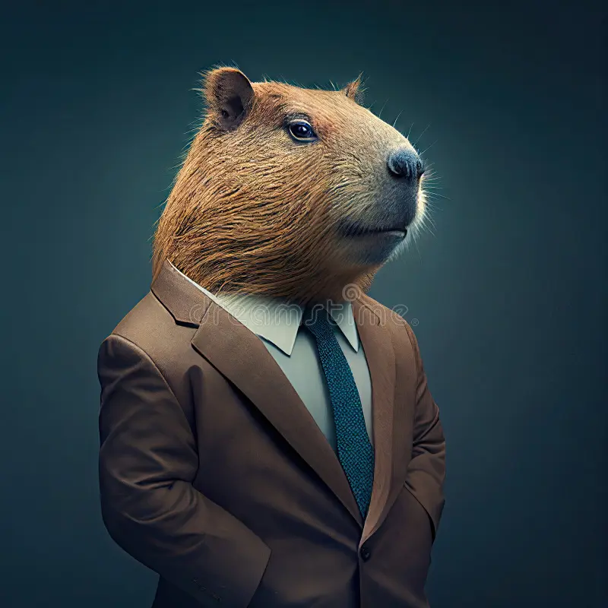
Figure 3.1: A capybara wearing a suit. Probably has an important meeting to get to.

3.3 Methods

3.3.1 Study System
Nam dui ligula, fringilla a, euismod sodales, sollicitudin vel, wisi. Morbi auctor lorem non justo. Nam lacus libero, pretium at, lobortis vitae, ultricies et, tellus. Donec aliquet, tortor sed accumsan bibendum, erat ligula aliquet magna, vitae ornare odio metus a mi. Morbi ac orci et nisl hendrerit mollis. Suspendisse ut massa. Cras nec ante. Pellentesque a nulla. Cum sociis natoque penatibus et magnis dis parturient montes, nascetur ridiculus mus. Aliquam tincidunt urna. Nulla ullamcorper vestibulum turpis. Pellentesque cursus luctus mauris.

3.3.2 Mathematical Model
Nulla malesuada porttitor diam. Donec felis erat, congue non, volutpat at, tincidunt tristique, libero. Vivamus viverra fermentum felis. Donec nonummy pellentesque ante. Phasellus adipiscing semper elit. Proin fermentum massa ac quam. Sed diam turpis, mo- lestie vitae, placerat a, molestie nec, leo. Maecenas lacinia. Nam ipsum ligula, eleifend at, accumsan nec, suscipit a, ipsum. Morbi blandit ligula feugiat magna. Nunc eleifend conse- quat lorem. Sed lacinia nulla vitae enim. Pellentesque tincidunt purus vel magna. Integer non enim. Praesent euismodnunc eupurus. Donec bibendumquam in tellus. Nullamcursus pulvinar lectus. Donec et mi. Nam vulputate metus eu enim. Vestibulum pellentesque felis eu massa.

$$\begin{aligned}\frac{∂u_{i}}{∂t}=\underset{\text{Random Motion}}{\underbrace{D∇^{2}u_{i}}}-\underset{\text{Directed Motion}}{\underbrace{2∇\left[A_{i}∇u_{i}\right]}}\#(Eq. 3.1)\end{aligned}$$

3.3.3 Statistical Model
Quisque ullamcorper placerat ipsum. Cras nibh. Morbi vel justo vitae lacus tincidunt ultrices. Lorem ipsum dolor sit amet, consectetuer adipiscing elit. In hac habitasse platea dictumst. Integer tempus convallis augue. Etiam facilisis. Nunc elementum fermentumwisi. Aenean placerat. Ut imperdiet, enim sed gravida sollicitudin, felis odio placerat quam, acpulvinar elit purus eget enim. Nunc vitae tortor. Proin tempus nibh sit amet nisl. Vivamus quis tortor vitae risus porta vehicula.
$$\begin{aligned}f\left(x | y, θ_{0}\right)= \frac{ϕ\left(x | y,θ_{0}\right) ω\left(x,β\right)}{\int_{Ω}{ϕ\left(x^{'} | y,{θ^{'}}_{0}\right) ω\left(x^{'},β\right)}}\#\left(Eq. 3.2\right)\end{aligned}$$

Table 3.1: Model components and parameters making up advection diffusion model as well as biological interpretation in model’s system.
Parameter | Interpretation | Dimensions
x | spatial location | [1x2]
u_{i}(x,t) | individual territory | [1x1] (i=5)
V_{hr} | vector field defining available space | [1x1]
B(x) | perceptive range of individual | [1x12]
s_{j}(x,t|B(x)) | Spatially averaged effect in perceptive range | [1x1] (j=4)
B^{C}_{i,j} | effect of conspecific (from iSSA) | [5x5]

3.4 Results
Lorem ipsum dolor sit amet, consectetuer adipiscing elit. Ut purus elit, vestibulum ut, placerat ac, adipiscing vitae, felis. Curabitur dictum gravida mauris. Nam arcu libero, nonummy eget, consectetuer id, vulputate a, magna. Donec vehicula augue eu neque. Pel- lentesque habitant morbi tristique senectus et netus et malesuada fames ac turpis egestas. Mauris ut leo. Cras viverra metus rhoncus sem. Nulla et lectus vestibulum urna fringilla ultrices. Phasellus eu tellus sit amet tortor gravida placerat. Integer sapien est, iaculis in, pretium quis, viverra ac, nunc. Praesent eget sem vel leo ultrices bibendum. Aenean faucibus. Morbi dolor nulla, malesuada eu, pulvinar at, mollis ac, nulla. Curabitur auctor semper nulla. Donec varius orci eget risus. Duis nibh mi, congue eu, accumsan eleifend, sagittis quis, diam. Duis eget orci sit amet orci dignissim rutrum.

3.4.1 Steady State Solution
Nam dui ligula, fringilla a, euismod sodales, sollicitudin vel, wisi. Morbi auctor lorem non justo. Nam lacus libero, pretium at, lobortis vitae, ultricies et, tellus. Donec aliquet, tortor sed accumsan bibendum, erat ligula aliquet magna, vitae ornare odio metus a mi. Morbi ac orci et nisl hendrerit mollis. Suspendisse ut massa. Cras nec ante. Pellentesque a nulla. Cum sociis natoque penatibus et magnis dis parturient montes, nascetur ridiculus mus. Aliquam tincidunt urna. Nulla ullamcorper vestibulum turpis. Pellentesque cursus luctus mauris.

Table 3.2: Counts of all the stuff, things, doodads, trinkets, artifacts, and entities.
Stuff | Things | Doodads | Trinkets | Artifacts | Entities
0 | 1 | 7 | 0 | 0 | 2
3 | 0 | 0 | 5 | 1 | 1
7 | 0 | 8 | 1 | 1 | 2
0 | 1 | 7 | 0 | 0 | 2
3 | 0 | 0 | 5 | 1 | 1
7 | 0 | 8 | 1 | 1 | 2
0 | 1 | 7 | 0 | 0 | 2
3 | 0 | 0 | 5 | 1 | 1
7 | 0 | 8 | 1 | 1 | 2
0 | 1 | 7 | 0 | 0 | 2
3 | 0 | 0 | 5 | 1 | 1
7 | 0 | 8 | 1 | 1 | 2
0 | 1 | 7 | 0 | 0 | 2
3 | 0 | 0 | 5 | 1 | 1
7 | 0 | 8 | 1 | 1 | 2
0 | 1 | 7 | 0 | 0 | 2
3 | 0 | 0 | 5 | 1 | 1
7 | 0 | 8 | 1 | 1 | 2
0 | 1 | 7 | 0 | 0 | 2
3 | 0 | 0 | 5 | 1 | 1
7 | 0 | 8 | 1 | 1 | 2
0 | 1 | 7 | 0 | 0 | 2
3 | 0 | 0 | 5 | 1 | 1
7 | 0 | 8 | 1 | 1 | 2
0 | 1 | 7 | 0 | 0 | 2
3 | 0 | 0 | 5 | 1 | 1
7 | 0 | 8 | 1 | 1 | 2

Table 3.2 cont’d.
Stuff | Things | Doodads | Trinkets | Artifacts | Entities
0 | 1 | 7 | 0 | 0 | 2
3 | 0 | 0 | 5 | 1 | 1
7 | 0 | 8 | 1 | 1 | 2
0 | 1 | 7 | 0 | 0 | 2
3 | 0 | 0 | 5 | 1 | 1
7 | 0 | 8 | 1 | 1 | 2
0 | 1 | 7 | 0 | 0 | 2
3 | 0 | 0 | 5 | 1 | 1
7 | 0 | 8 | 1 | 1 | 2
0 | 1 | 7 | 0 | 0 | 2
3 | 0 | 0 | 5 | 1 | 1
7 | 0 | 8 | 1 | 1 | 2
0 | 1 | 7 | 0 | 0 | 2
3 | 0 | 0 | 5 | 1 | 1
7 | 0 | 8 | 1 | 1 | 2
0 | 1 | 7 | 0 | 0 | 2
3 | 0 | 0 | 5 | 1 | 1
7 | 0 | 8 | 1 | 1 | 2
0 | 1 | 7 | 0 | 0 | 2
3 | 0 | 0 | 5 | 1 | 1
7 | 0 | 8 | 1 | 1 | 2
0 | 1 | 7 | 0 | 0 | 2
3 | 0 | 0 | 5 | 1 | 1
7 | 0 | 8 | 1 | 1 | 2
0 | 1 | 7 | 0 | 0 | 2
3 | 0 | 0 | 5 | 1 | 1
7 | 0 | 8 | 1 | 1 | 2

3.4.2 Non-territorial Individual Analysis
Nulla malesuada porttitor diam. Donec felis erat, congue non, volutpat at, tincidunt tristique, libero. Vivamus viverra fermentum felis. Donec nonummy pellentesque ante. Phasellus adipiscing semper elit. Proin fermentum massa ac quam. Sed diam turpis, mo- lestie vitae, placerat a, molestie nec, leo. Maecenas lacinia. Nam ipsum ligula, eleifend at, accumsan nec, suscipit a, ipsum. Morbi blandit ligula feugiat magna. Nunc eleifend conse- quat lorem. Sed lacinia nulla vitae enim. Pellentesque tincidunt purus vel magna. Integer non enim. Praesent euismodnunc eupurus. Donec bibendumquam in tellus. Nullamcursus pulvinar lectus. Donec et mi. Nam vulputate metus eu enim. Vestibulum pellentesque felis eu massa.

3.5 Discussion
Fusce mauris. Vestibulum luctus nibh at lectus. Sed bibendum, nulla a faucibus semper, leo velit ultricies tellus, ac venenatis arcu wisi vel nisl. Vestibulum diam. Aliquam pellen- tesque, augue quis sagittis posuere, turpis lacus congue quam, in hendrerit risus eros eget felis. Maecenas eget erat in sapien mattis porttitor. Vestibulum porttitor. Nulla facilisi. Sed a turpis eu lacus commodo facilisis. Morbi fringilla, wisi in dignissim interdum, justo lectus sagittis dui, et vehicula libero dui cursus dui. Mauris tempor ligula sed lacus. Duis cursus enim ut augue. Cras ac magna. Cras nulla. Nulla egestas. Curabitur a leo. Quisque egestas wisi eget nunc. Nam feugiat lacus vel est. Curabitur consectetuer.

3.6 References
Einstein, A., Darwin, C. & Linnaeus, C. (1425) The hungry hungry moose. Journal of Hungry Animals. 3, 2150–8925.
Styles, H., Horan, N., Payne, L., Tomlinson, L. &Malik, Z. (1985) How many directions are there: Only the one. Scandinavian Journal of Music. 12, 97–15.

General Conclusions
Nulla malesuada porttitor diam. Donec felis erat, congue non, volutpat at, tincidunt tristique, libero. Vivamus viverra fermentum felis. Donec nonummy pellentesque ante. Phasellus adipiscing semper elit. Proin fermentum massa ac quam. Sed diam turpis, mo- lestie vitae, placerat a, molestie nec, leo. Maecenas lacinia. Nam ipsum ligula, eleifend at, accumsan nec, suscipit a, ipsum. Morbi blandit ligula feugiat magna. Nunc eleifend conse- quat lorem. Sed lacinia nulla vitae enim. Pellentesque tincidunt purus vel magna. Integer non enim. Praesent euismodnunc eupurus. Donec bibendumquam in tellus. Nullamcursus pulvinar lectus. Donec et mi. Nam vulputate metus eu enim. Vestibulum pellentesque felis eu massa

Supplemental Material
Nulla malesuada porttitor diam. Donec felis erat, congue non, volutpat at, tincidunt tristique, libero. Vivamus viverra fermentum felis. Donec nonummy pellentesque ante. Phasellus adipiscing semper elit. Proin fermentum massa ac quam. Sed diam turpis, mo- lestie vitae, placerat a, molestie nec, leo. Maecenas lacinia. Nam ipsum ligula, eleifend at, accumsan nec, suscipit a, ipsum. Morbi blandit ligula feugiat magna. Nunc eleifend conse- quat lorem. Sed lacinia nulla vitae enim. Pellentesque tincidunt purus vel magna. Integer non enim. Praesent euismodnunc eupurus. Donec bibendumquam in tellus. Nullamcursus pulvinar lectus. Donec et mi. Nam vulputate metus eu enim. Vestibulum pellentesque felis eu massa.

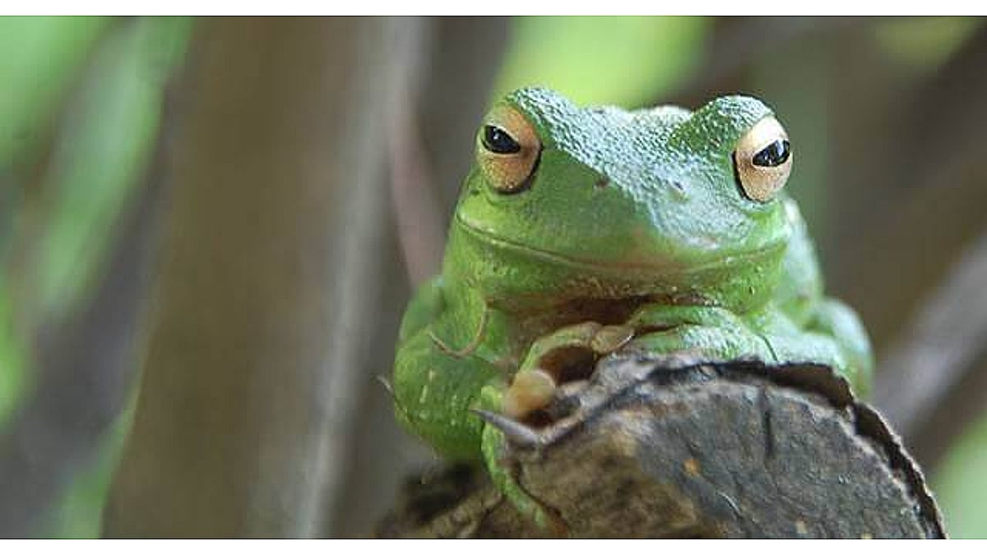
Figure A.1: Frog looking real dapper.

Appendix B: More Supplemental Material
Sed commodo posuere pede. Mauris ut est. Ut quis purus. Sed ac odio. Sed vehicula hendrerit sem. Duis non odio. Morbi ut dui. Sed accumsan risus eget odio. In hac habitasse platea dictumst. Pellentesque non elit. Fusce sedjusto eu urna porta tincidunt. Mauris felis odio, sollicitudin sed, volutpat a, ornare ac, erat. Morbi quis dolor. Donec pellentesque, erat ac sagittis semper, nunc dui lobortis purus, quis congue purus metus ultricies tellus. Proin et quam. Class aptent taciti sociosqu ad litora torquent per conubia nostra, per inceptos hymenaeos. Praesent sapien turpis, fermentum vel, eleifend faucibus, vehicula eu, lacus.

