INVENTING THE SUIT AND SAVING THE WORLD: ONE HUMAN’S STORY OF UNPARALLELED GENIUS, INTERMINABLE COURAGE, AND GENERAL AWESOMENESS

by
Anthony Stark
B.S. University of Pirates, 2017

A Thesis Submitted in Partial Fulfillment of the Requirements
for the Degree of

Master of Fine Arts
in
Photography

University of Alaska Fairbanks
August 2025

APPROVED:
Bruce Banner, Committee Chair
Thor Odinson, Committee Member
Natasha Romonoff, Committee Member
Jane Van Dyne, Committee Member
Clinton F. Barton, Chair
Department of Mechanical Engineering
Jean Gray, Dean
College of Business and Security Management
Emeline Jones, Director
Graduate School

Copyright

© Copyright by Anthony Stark
All Rights Reserved

Dedication
To Wanda Maximoff:

Write as a block (or single paragraph) with no indentation. The dedication is optional. A dedication is an expression of friendly connection, gratitude, or thanks by the author towards another person or person(s). It may also be used to highlight a connection to a community or cause. Adapted from Wikipedia. The dedication has its own place on the dedication page and is part of the front matter.

Abstract
Abstract to be less than 300 words. The abstract is required. Write as a single block with no indentation. An abstract is a concise summary of your dissertation. It should summarize your dissertation, its results, and its broader relevance. It allows readers determine the relevance of your dissertation to their own research and serves as an invitation to them to read it. It also communicates your key findings to those who don’t have the time to read your entire dissertation.

Plain Word Summary
Plain word summary to be less than 300 words. The plain word summary is optional. Write as a single block without indentation. A plain word summary should convey the same information as the abstract but in a different language and tone. It should summarize your dissertation, its results, and their broader relevance without using jargon so that it is understandable by readers from outside of your discipline, as well as journalists and educators. The audiences include, but are not limited to, practitioners, policy makers, the public, and/or professionals in nearby disciplines.

Acknowledgements
Write as a paragraph, or paragraphs, with indentation. The acknowledgements section is optional. The acknowledgments section is where you recognize and thank everyone (mentor/advisor committee, friends, family, colleagues, communities, organizations, agencies) who helped you with your dissertation and contributed to your success. It’s a way to show your appreciation and recognition of them in a public and permanent forum. You can also include a Land Acknowledgement in the acknowledgements. It is also the section where you can formally report any agencies and organizations that provided financial or other material support for your work (e.g., I acknowledge the support of the UAF graduate school for …., I thank Foundation X for ….). I acknowledge the support of the graduate school for a travel grant in Fall 2022. I acknowledge the support of the National Science Foundation under grant 2012345.

Table of Contents

Copyright iii
Dedication iv
Abstract v
Plain Word Summary vi
Acknowledgements vii
Table of Contents viii
List of Figures x
List of Tables xi
Main Heading 1
Main Heading 2
Sub-heading 2
Sub-heading 2
Main Heading 3
Sub-heading 3
Sub-heading 3
Sub-sub-heading 3
Direct Quotes 5
Long ToC entries should not extend into the page number column. They should stop before reaching the number 5
Main Heading 6
References 7
Appendix A: Supplemental Material 8
Appendix B: More Supplemental Material 9

List of Figures
Figure A.1: Frog looking real dapper. 8

List of Tables
No table of figures entries found.

Main Heading
Lorem ipsum dolor sit amet, consectetuer adipiscing elit. Ut purus elit, vestibulum ut, placerat ac, adipiscing vitae, felis. Curabitur dictum gravida mauris. Nam arcu libero, nonummy eget, consectetuer id, vulputate a, magna. Donec vehicula augue eu neque. Pel- lentesque habitant morbi tristique senectus et netus et malesuada fames ac turpis egestas. Mauris ut leo. Cras viverra metus rhoncus sem. Nulla et lectus vestibulum urna fringilla ultrices. Phasellus eu tellus sit amet tortor gravida placerat. Integer sapien est, iaculis in, pretium quis, viverra ac, nunc. Praesent eget sem vel leo ultrices bibendum. Aenean faucibus. Morbi dolor nulla, malesuada eu, pulvinar at, mollis ac, nulla. Curabitur auctor semper nulla. Donec varius orci eget risus. Duis nibh mi, congue eu, accumsan eleifend, sagittis quis, diam. Duis eget orci sit amet orci dignissim rutrum.

Main Heading

Sub-heading
These sub-headings should be relevant to your work.

Sub-heading
If you decide to embed figures in your document, you must mention that figure within 1.5 pages of where that figure is found. Figure labels and captions belong below the figure on the same page as the figure.

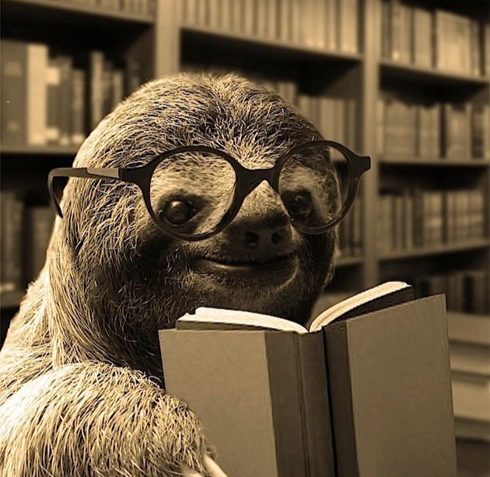
Figure 1: A very studious and well-read sloth just got a new pair of eyeglasses and wonders if others love them as much as he does.

Main Heading

Sub-heading
Lorem ipsum dolor sit amet, consectetuer adipiscing elit. Ut purus elit, vestibulum ut, placerat ac, adipiscing vitae, felis. Curabitur dictum gravida mauris. Nam arcu libero, nonummy eget, consectetuer id, vulputate a, magna. Donec vehicula augue eu neque. Pel- lentesque habitant morbi tristique senectus et netus et malesuada fames ac turpis egestas. Mauris ut leo. Cras viverra metus rhoncus sem. Nulla et lectus vestibulum urna fringilla ultrices. Phasellus eu tellus sit amet tortor gravida placerat. Integer sapien est, iaculis in, pretium quis, viverra ac, nunc. Praesent eget sem vel leo ultrices bibendum. Aenean faucibus. Morbi dolor nulla, malesuada eu, pulvinar at, mollis ac, nulla. Curabitur auctor semper nulla. Donec varius orci eget risus. Duis nibh mi, congue eu, accumsan eleifend, sagittis quis, diam. Duis eget orci sit amet orci dignissim rutrum.

Sub-heading
Lorem ipsum dolor sit amet, consectetuer adipiscing elit. Ut purus elit, vestibulum ut, placerat ac, adipiscing vitae, felis. Curabitur dictum gravida mauris. Nam arcu libero, nonummy eget, consectetuer id, vulputate a, magna. Donec vehicula augue eu neque. Pel- lentesque habitant morbi tristique senectus et netus et malesuada fames ac turpis egestas. Mauris ut leo. Cras viverra metus rhoncus sem. Nulla et lectus vestibulum urna fringilla ultrices. Phasellus eu tellus sit amet tortor gravida placerat. Integer sapien est, iaculis in, pretium quis, viverra ac, nunc. Praesent eget sem vel leo ultrices bibendum. Aenean faucibus. Morbi dolor nulla, malesuada eu, pulvinar at, mollis ac, nulla. Curabitur auctor semper nulla. Donec varius orci eget risus. Duis nibh mi, congue eu, accumsan eleifend, sagittis quis, diam. Duis eget orci sit amet orci dignissim rutrum.

Sub-sub-heading
Mauris ut leo. Cras viverra metus rhoncus sem. Nulla et lectus vestibulum urna fringilla ultrices. Phasellus eu tellus sit amet tortor gravida placerat. Integer sapien est, iaculis in, pretium quis, viverra ac, nunc. Praesent eget sem vel leo ultrices bibendum.

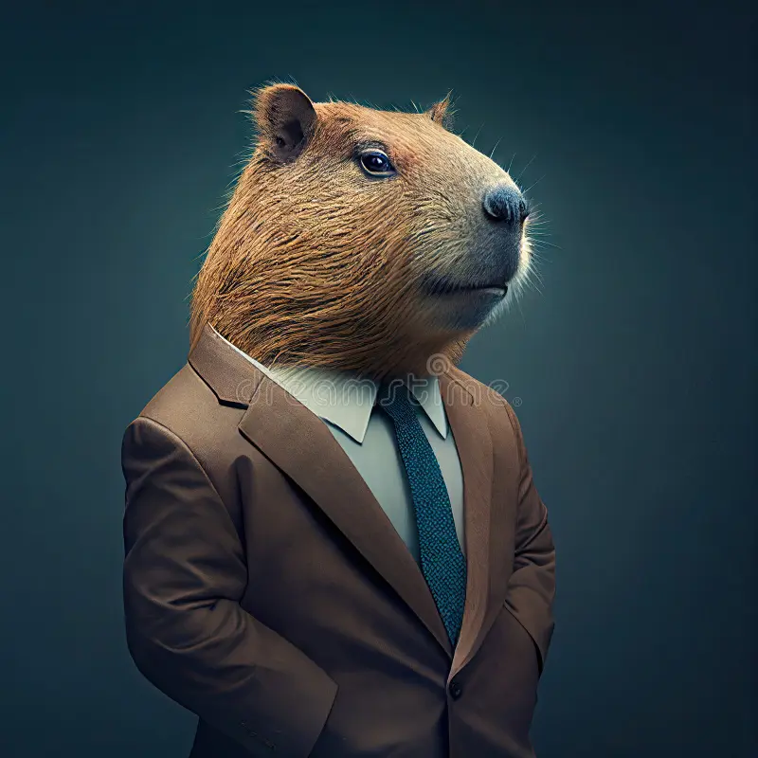
Figure 2: A capybara wearing a suit. Probably has an important meeting to get to.
Lorem ipsum dolor sit amet, consectetuer adipiscing elit. Ut purus elit, vestibulum ut, placerat ac, adipiscing vitae, felis. Curabitur dictum gravida mauris. Nam arcu libero, nonummy eget, consectetuer id, vulputate a, magna. Donec vehicula augue eu neque. Pel- lentesque habitant morbi tristique senectus et netus et malesuada fames ac turpis egestas. Mauris ut leo. Cras viverra metus rhoncus sem. Nulla et lectus vestibulum urna fringilla ultrices. Phasellus eu tellus sit amet tortor gravida placerat. Integer sapien est, iaculis in, pretium quis, viverra ac, nunc. Praesent eget sem vel leo ultrices bibendum. Aenean faucibus. Morbi dolor nulla, malesuada eu, pulvinar at, mollis ac, nulla. Curabitur auctor semper nulla. Donec varius orci eget risus. Duis nibh mi, congue eu, accumsan eleifend, sagittis quis, diam. Duis eget orci sit amet orci dignissim rutrum. Mauris ut leo. Cras viverra metus rhoncus sem. Nulla et lectus vestibulum urna fringilla ultrices. Phasellus eu tellus sit amet tortor gravida placerat. Integer sapien est, iaculis in, pretium quis, viverra ac, nunc. Praesent eget sem vel leo ultrices bibendum. Lorem ipsum dolor sit amet, consectetuer adipiscing elit. Ut purus elit, vestibulum ut, placerat ac, adipiscing vitae, felis. Curabitur dictum gravida mauris. Nam arcu libero, nonummy eget, consectetuer id, vulputate a, magna.

Direct Quotes
If you include direct quotes that are only one-to-two sentences, please put them in quotations. For example, Participant one “said that they like cookies with ice cream but would choose ice cream over cookies if they had to chose only one”. If you are including quotes that are longer, more like the length of a paragraph, put it in block form like the following example. Participant 1 said:
I’ve always liked cookies, sure, but ice cream has my heart, there’s just nothing like it. The texture, the flavors, the way it melts, is unbeatable. Cookies are good, but they don’t quite do it for me on their own. But put the two together? That’s where the magic happens. A warm cookie with cold, creamy ice cream in the middle? That’s my ultimate favorite; nothing beats that combo.

Long ToC entries should not extend into the page number column. They should stop before reaching the number
Lorem ipsum dolor sit amet, consectetuer adipiscing elit. Ut purus elit, vestibulum ut, placerat ac, adipiscing vitae, felis. Curabitur dictum gravida mauris. Nam arcu libero, nonummy eget, consectetuer id, vulputate a, magna. Donec vehicula augue eu neque. Pel- lentesque habitant morbi tristique senectus et netus et malesuada fames ac turpis egestas. Mauris ut leo. Cras viverra metus rhoncus sem. Nulla et lectus vestibulum urna fringilla ultrices. Phasellus eu tellus sit amet tortor gravida placerat. Integer sapien est, iaculis in, pretium quis, viverra ac, nunc. Praesent eget sem vel leo ultrices bibendum. Aenean faucibus. Morbi dolor nulla, malesuada eu, pulvinar at, mollis ac, nulla. Curabitur auctor semper nulla. Donec varius orci eget risus. Duis nibh mi, congue eu, accumsan eleifend, sagittis quis, diam. Duis eget orci sit amet orci dignissim rutrum.

Main Heading
Nulla malesuada porttitor diam. Donec felis erat, congue non, volutpat at, tincidunt tristique, libero. Vivamus viverra fermentum felis. Donec nonummy pellentesque ante. Phasellus adipiscing semper elit. Proin fermentum massa ac quam. Sed diam turpis, mo- lestie vitae, placerat a, molestie nec, leo. Maecenas lacinia. Nam ipsum ligula, eleifend at, accumsan nec, suscipit a, ipsum. Morbi blandit ligula feugiat magna. Nunc eleifend conse- quat lorem. Sed lacinia nulla vitae enim. Pellentesque tincidunt purus vel magna. Integer non enim. Praesent euismodnunc eupurus. Donec bibendumquam in tellus. Nullamcursus pulvinar lectus. Donec et mi. Nam vulputate metus eu enim. Vestibulum pellentesque felis eu massa.

Nulla malesuada porttitor diam. Donec felis erat, congue non, volutpat at, tincidunt tristique, libero. Vivamus viverra fermentum felis. Donec nonummy pellentesque ante. Phasellus adipiscing semper elit. Proin fermentum massa ac quam. Sed diam turpis, mo- lestie vitae, placerat a, molestie nec, leo. Maecenas lacinia. Nam ipsum ligula, eleifend at, accumsan nec, suscipit a, ipsum. Morbi blandit ligula feugiat magna. Nunc eleifend conse- quat lorem. Sed lacinia nulla vitae enim. Pellentesque tincidunt purus vel magna. Integer non enim. Praesent euismodnunc eupurus. Donec bibendumquam in tellus. Nullamcursus pulvinar lectus. Donec et mi. Nam vulputate metus eu enim. Vestibulum pellentesque felis eu massa.

Nulla malesuada porttitor diam. Donec felis erat, congue non, volutpat at, tincidunt tristique, libero. Vivamus viverra fermentum felis. Donec nonummy pellentesque ante. Phasellus adipiscing semper elit. Proin fermentum massa ac quam. Sed diam turpis, mo- lestie vitae, placerat a, molestie nec, leo. Maecenas lacinia. Nam ipsum ligula, eleifend at, accumsan nec, suscipit a, ipsum. Morbi blandit ligula feugiat magna. Nunc eleifend conse- quat lorem. Sed lacinia nulla vitae enim. Pellentesque tincidunt purus vel magna. Integer non enim. Praesent euismodnunc eupurus. Donec bibendumquam in tellus. Nullamcursus pulvinar lectus. Donec et mi. Nam vulputate metus eu enim. Vestibulum pellentesque felis eu massa.

References
Einstein, A., Darwin, C. & Linnaeus, C. (1425) The hungry hungry moose. Journal of Hungry Animals. 3, 2150–8925.
Styles, H., Horan, N., Payne, L., Tomlinson, L. &Malik, Z. (1985) How many directions are there: Only the one. Scandinavian Journal of Music. 12, 97–15.

Supplemental Material
Nulla malesuada porttitor diam. Donec felis erat, congue non, volutpat at, tincidunt tristique, libero. Vivamus viverra fermentum felis. Donec nonummy pellentesque ante. Phasellus adipiscing semper elit. Proin fermentum massa ac quam. Sed diam turpis, mo- lestie vitae, placerat a, molestie nec, leo. Maecenas lacinia. Nam ipsum ligula, eleifend at, accumsan nec, suscipit a, ipsum. Morbi blandit ligula feugiat magna. Nunc eleifend conse- quat lorem. Sed lacinia nulla vitae enim. Pellentesque tincidunt purus vel magna. Integer non enim. Praesent euismodnunc eupurus. Donec bibendumquam in tellus. Nullamcursus pulvinar lectus. Donec et mi. Nam vulputate metus eu enim. Vestibulum pellentesque felis eu massa.

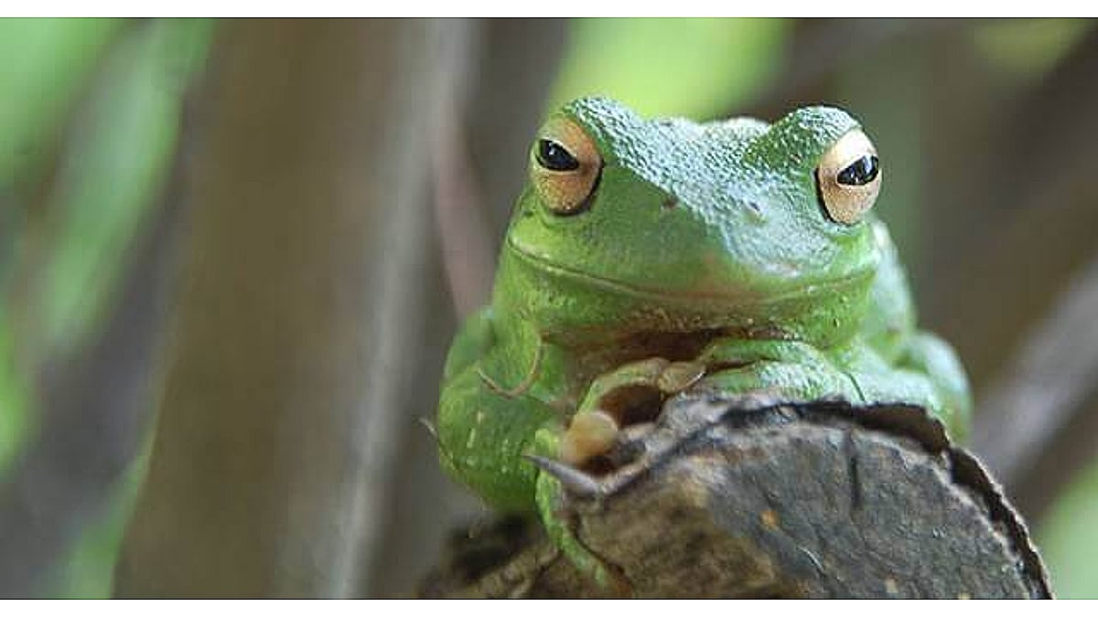
Figure A.1: Frog looking real dapper.

Appendix B: More Supplemental Material
Sed commodo posuere pede. Mauris ut est. Ut quis purus. Sed ac odio. Sed vehicula hendrerit sem. Duis non odio. Morbi ut dui. Sed accumsan risus eget odio. In hac habitasse platea dictumst. Pellentesque non elit. Fusce sedjusto eu urna porta tincidunt. Mauris felis odio, sollicitudin sed, volutpat a, ornare ac, erat. Morbi quis dolor. Donec pellentesque, erat ac sagittis semper, nunc dui lobortis purus, quis congue purus metus ultricies tellus. Proin et quam. Class aptent taciti sociosqu ad litora torquent per conubia nostra, per inceptos hymenaeos. Praesent sapien turpis, fermentum vel, eleifend faucibus, vehicula eu, lacus.

