So first off, you must have Administrator privileges on the computer you are using so that you can be able to do all the downloads. If you don’t have it, please ask your supervisor to submit a ticket with OIT to allow you to have it.
Once you have Administrator privileges on your computer go to https://www.foxit.com/downloads/ under "Windows Add-Ons".
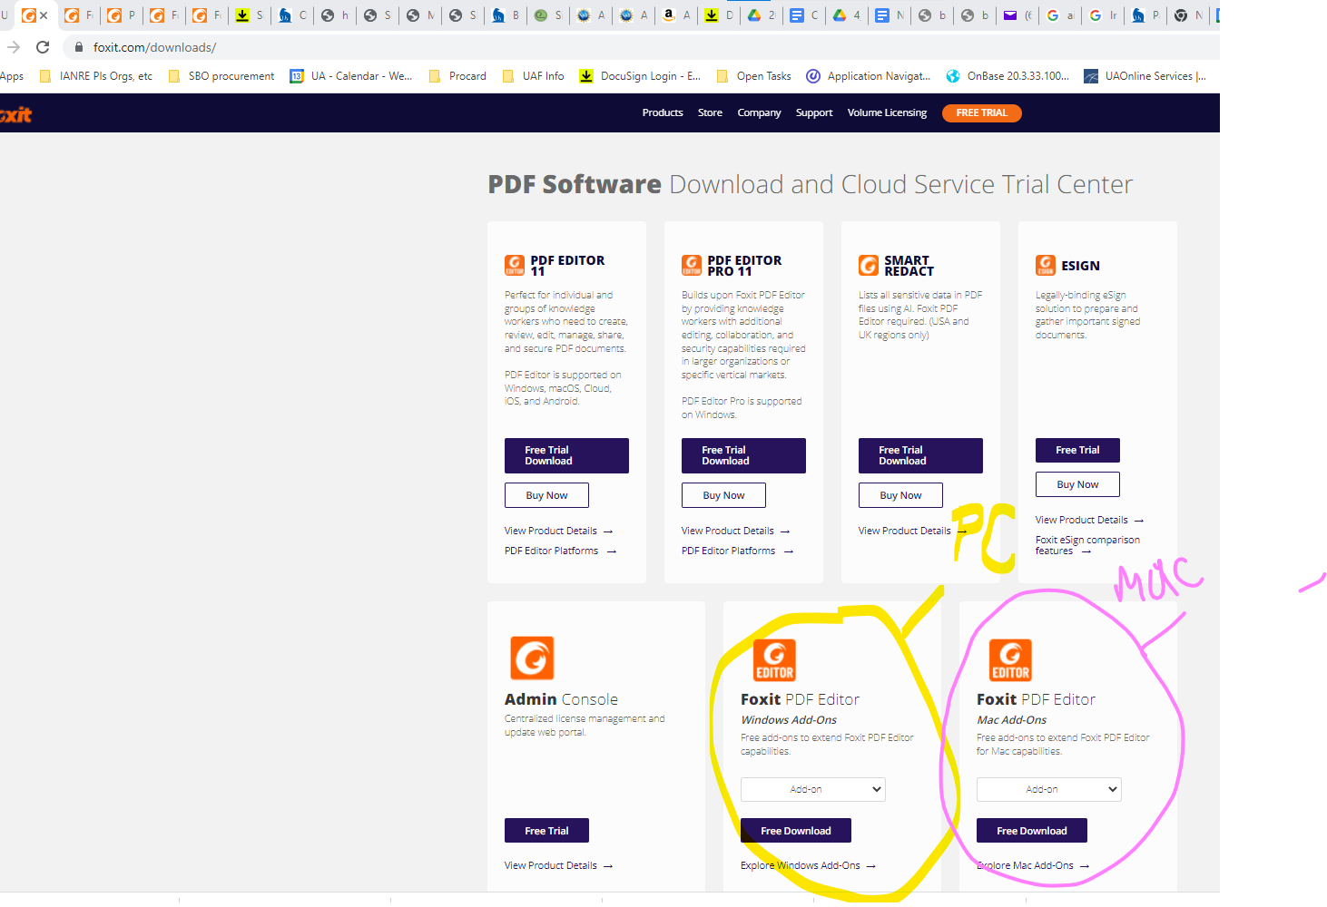
Then go to Help > Foxit Plug-Ins and click Install Plugin to install the plugin. (It's at the very bottom of the choices….)https://www.foxit.com/pdf-editor/addons.html?product=phantompdf ….we have version 11.2 for Foxit.
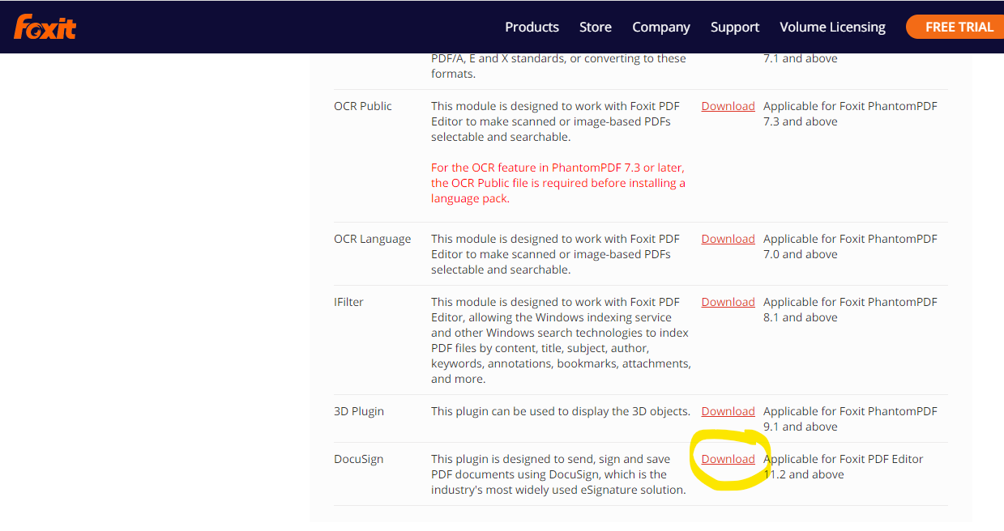

If you need to combine files in Foxit, you go to “Convert” then select Combine Files…if you need them in a particular order you can do that once they are combined via the little pages on the left sidebar. Just drop and drag them into the order you want them to be.
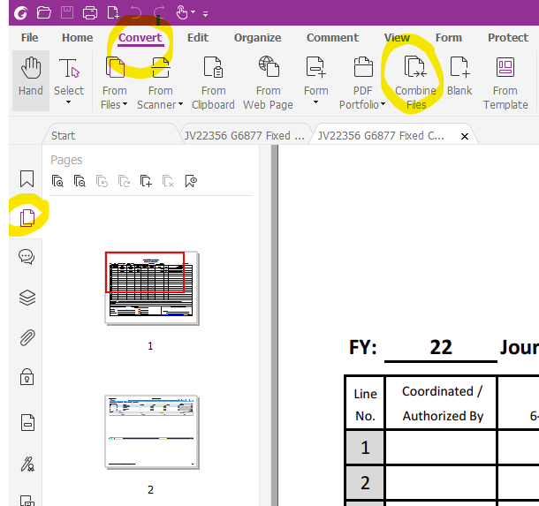

So when you want to send something through Docusign (make sure to print it to PDF first) via the Foxit PDF Editor, go to Protect at the top, then select Docusign (drop down to send via Docusign). Once there you will need to either select the left arrow on the far left of the blue bar (circled with green) to be able to assign the document to multiple people or the “ADD RECIPIENTS” right below that…either way gets you there.
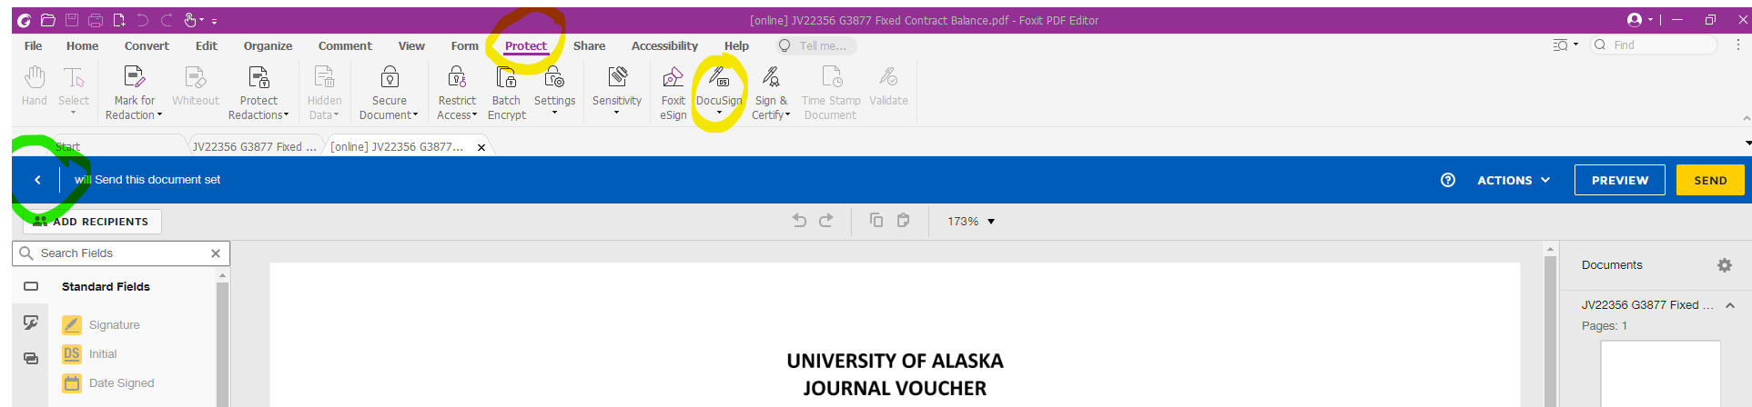

The rest is just like you would normally do it in Docusign. It does come through on the email a little differently, see below:
