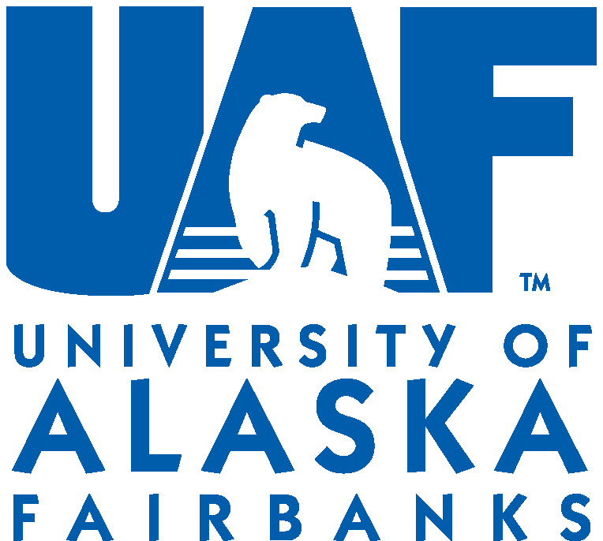
Proposed UAF Policy ___________
Original Adoption: ___________
Revised: ___________
Responsible Chancellor’s Cabinet Member: ___________
Responsible Department/Office: ___________

[field] Policy

POLICY STATEMENT
[field]

BACKGROUND & JUSTIFICATION
[field]

DEFINITIONS
[field]

REFERENCES RELIED UPON
[field]

RESPONSIBILITIES
[field]

NON-COMPLIANCE
[field]

EXCEPTIONS
[field]
PROCEDURES
[field]

POLICY APPROVED BY:

__________________________________________ Signed:
Brian D. Rogers, Chancellor
University of Alaska Fairbanks

