Grant Effort Certification – Certification Statement Printing Process
Go to: “FGR2CRT” and ‘enter’
Once “FGR2CRT – Effort Certification Statement” appears at the top, ‘ctrl page down’ to the Printer Control. The Parameter Set will stay blank.
The Printer Control will default to “Database”. Change this to the appropriate printer you wish to use. Click the drop down arrow to search for the correct printer. You’ll see some funny letters and numbers in the Special Print section; leave this. Click over to Template and type “evi_fgr2crt”, then ‘ctrl page down’ to the Parameter Values. It will automatically update the Special Print section.
All Parameter Values, if they are letters, need to be in CAPS. Each value will be correspond to whatever period you are requesting, as well as which TKL and/or employee to whom you are sending the report.
Year – ex. 2014
Certification Period – ex. SUMMER
TKL – ex. T203
Employee ID – ex. 30000000
Note: If you want to pull an entire TKL, leave the Employee ID field blank. If you want to pull an employee only, leave the TKL field blank.
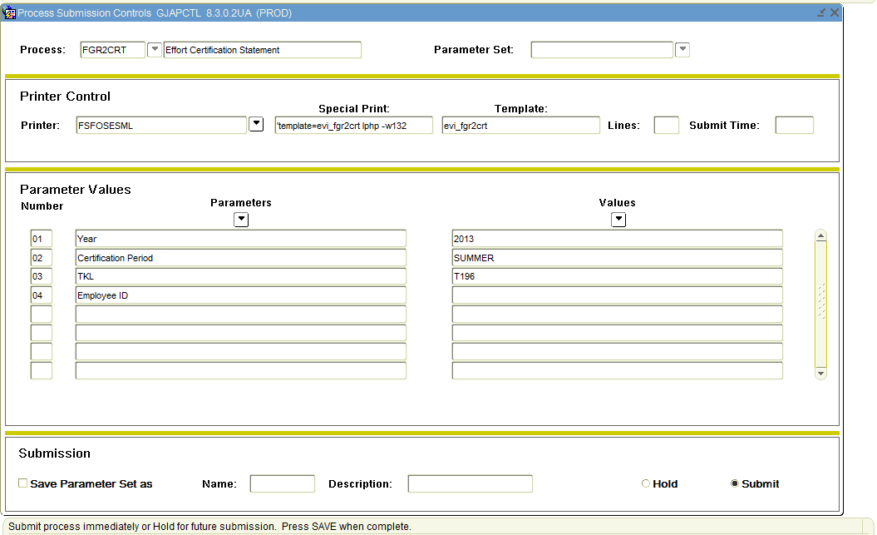
Once all Parameter Values have been set, ‘ctrl page down’. ‘F10’ to print.

